School of Sanctuary
Book List To Support Understanding of Refugees and Migration
Book | Date | Focus
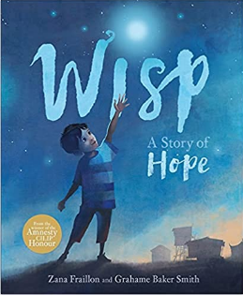 | 23/01/21 | Idris is a child refugee, born into a world of tents and fences. He has known no other life than this. He has no memories of the world outside.  Then the Wisp arrives, floating in on the evening breeze. Everyone who holds it finds their memories reawakened, their hopes of freedom reborn. But what about Idris, who has no memories? What will happen when he holds the magical Wisp?  Storytelling and imagination have the power to offer hope in this extraordinary picture book from the Amnesty CILIP Honour-winning author of The Bone Sparrow, Zana Fraillon, and Kate Greenaway Medal-winning illustrator Grahame Baker Smith.
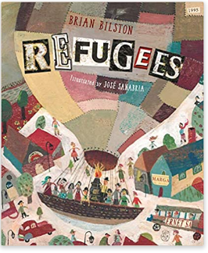 | 28/09/22 | The world is undergoing a period of mass human migration. Whether this is caused by war, persecution or economics, the people we see on the news in those camps are waiting – waiting to live their lives. There are two sides to every debate. There are two sides to a wall.  This story shows both sides of the issue with skill and the illustrations depict the issue in a magic realism style, powerful but never frightening, and will promote a deeper discussion on this topic with an older child.
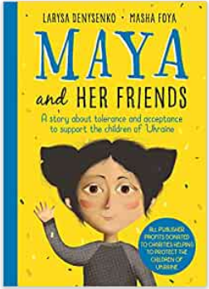 | 23/04/22 | Since the occupation of Crimea in 2014, Ukrainian families with children have had to live their daily lives in the shadow of the threat of war. Maya and Her Friends tells the story of ordinary Ukrainian children and their families.  Nine-year-old Maya has 16 classmates, all with different home backgrounds. Sofia's father has disappeared in the battles against Russia. When the war ends, he will hopefully be found. Aksana lives with her father because her mother is dead. Hristina lives with her grandmother because her parents are working abroad. Rais is a Crimean Tatar whose family had to leave his homeland due to the Russian occupation. Timko's parents are divorced, and he lives alternately with his mother and father. Petro is a Roma and has a huge family clan. Maya herself, on the other hand, has two mothers.
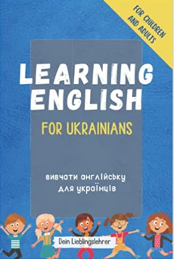 | 23/04/22 | The most important words English - Ukrainian! For children and all Ukrainians who want to start learning English, but also for English People who want to learn a little bit of Ukrainian.  Divided into 9 categories from everyday life, the book contains countless translations and an illustration for each term in order to visually reinforce what has been learned. The words and pictures are lovingly selected from the daily living environment of children.  In the chapter "It's your turn", which follows after each category, there is the possibility to check what you have learned.  The book contains the most important words from the following categories: Nature, Eat and Drink, At home, Animals, Family, School, Technology, Leisure, Body
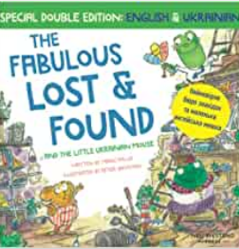 | 23/04/22 | First, is the heartwarming English story with 50 Ukrainian words: The Fabulous Lost and Found and the little Ukrainian mouse. Then, this is followed by the same story, but this time, in the Ukrainian language to learn 50 words in English: Неймовірне бюро знахідок та маленька англійська мишка (Fabulous Lost and Found and the English mouse).
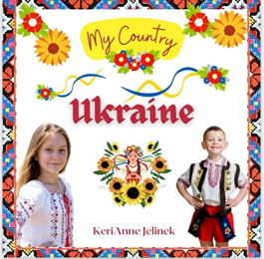 | 23/04/22 | Take a trip around the world to the beautiful country of Ukraine. Come explore the beauty of the Ukrainian people and the ancient traditions, culture, music, art, and world-famous landmarks.  Learn all about Ukrainian culture, Ukraine's heritage and what makes this Golden Country shine. Engage in the culture while learning facts about Ukrainian customs, money and even the features that make them unique!  A perfect book for falling in love with traveling, social studies, and the wonderful world around your young reader.
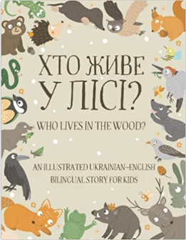 | 23/04/22 | Who Lives in the Wood? is a bilingual story featuring different woodland animals.  About the book:  - Short simple sentences – easy even for beginners.  - Every sentence comes with its own illustration and translation.  - Includes a chart with woodland animals and their names.  - Includes bonus Woodland Animals board game at the end of the book.
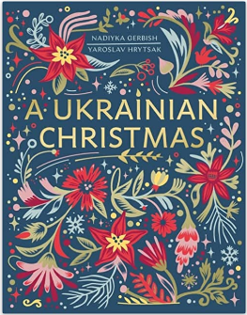 | 30/11/22 | 'Christmas brings the indestructibility of hope in times of the greatest hopelessness. As long as we celebrate this holiday, we can neither be defeated nor destroyed. This is the message that Ukraine is trying to convey to the world. And this is what our book is about.'  From Christmas music to gifts and food, as well as a look back through the country's rich and troubled history through the perspective of the festive season, this beautifully illustrated and powerful book introduces readers to Ukraine's unique Christmas traditions. In a country where East and West meet, this is a fascinating and unmissable guide to capturing the spirit of one of the most important times of year and a powerful reminder of the strength of holding on to your culture and beliefs, even as others try to take everything from you.
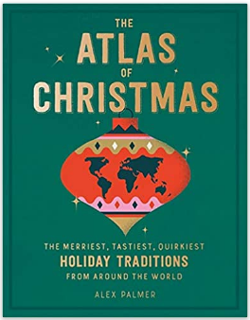 | 30/11/22 | Do you know that in Guatemala there's a "Burn the Devil" tradition to kick off the Christmas season, where people gather to set fire to devil-piñatas? Or that in Sweden, a popular figure in Christmas traditions is the Yule Goat, a rowdy, menacing character who demands gifts? Serbian men traditionally throw grain and corn at a tree, then kiss its bark, before they cut it down to make a Yule Log. And in Japan, a big bucket of Kentucky Fried Chicken has become the classic Christmas Day feast. These and many other global Christmas traditions are featured here in this delightful little book. From decorations and activities to feasts and special treats, there's a wide range of both lovely and unusual traditions from around the globe.
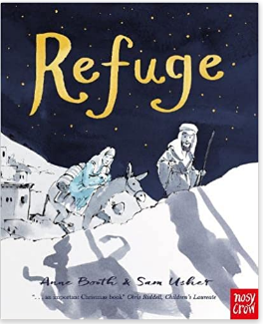 | 11/22 | A timely and timeless retelling of the Christmas story, inspired by refugee children everywhere.  This powerful and evocative picture book, which tells the Christmas story and what follows the fleeing of Jesus, Mary and Joseph from Herod's soldiers to Egypt has timeless crossover appeal and a poignant message that couldn't be more relevant.  There are such lovely details and touching descriptions which emphasise the vulnerability of the refugee, but love and courage runs through the narrative.
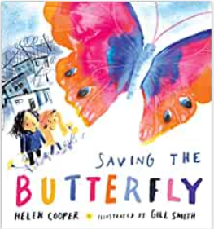 | 11/22 | A little brother and his big sister try their best to settle in a new home, where they have nothing left from before except each other. The little one makes new friends and quickly learns to laugh again but his sister remains haunted by the shadows of their past and hides away in their broken house. Trying to help his sister, the little one catches a butterfly for her and brings it inside the house. His sister knows that she needs to set the butterfly free ... but that would mean going outside. In taking the first steps to face her fears and save the butterfly, she also begins the process of saving herself.
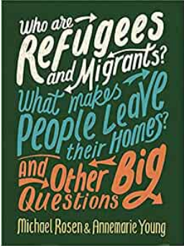 | 11/22 | This book explores the history of refugees and migration around the world and the effects on people of never-ending war and conflict. It compares the effects on society of diversity and interculturalism with historical attempts to create a racially 'pure' culture. It takes an international perspective, and offers a range of views from people who have personal experience of migration, including the campaigners Meltem Avcil and Muzoon Almellehan, the comedian and actor Omid Djalili and the poet Benjamin Zephaniah. Aimed at young people aged 10 and upwards, the book encourages readers to think for themselves about the issues involved. There is also a role-play activity asking readers to imagine themselves in the situation of having to decide whether to leave their homes and seek refuge in a new country.
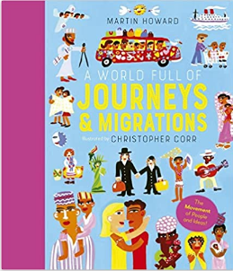 | 12/22 | Since the dawn of time, people have travelled to distant lands for many different reasons; to escape war, famine or injustice, to find work, or to simply see new sights and have an adventure. But everyone who migrates does it to seek a brighter future.  A World Full of Journeys is an illustrated book which tells some of the most fascinating stories of migration throughout history. From the very first humans who left Africa almost 70,000 years ago and moved around the world, to immigrants welcomed to America at Ellis Island, this book is packed with fascinating tales of human triumph.  Beautifully illustrated with bright pictures to engage younger readers and maps detailing these migrants' journeys bring these stories to life. From Viking sea traders and Roman armies marching through Europe to Huegenot refugees fleeing persecution from the Catholic church and migrants travelling from the Caribbean to Britain as part of the Windrush Generation, this book explores the fascinating stories of the people who have crossed the world.  With chapters including Africa, Oceania, Europe and the Americas, this book looks all across the world to tell the full story of our journeys throughout history.
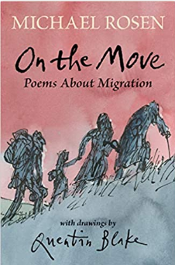 | 11/22 | "What you leave behind  Won't leave your mind.  But home is where you find it.  Home is where you find it."  Michael Rosen and Sir Quentin Blake join forces for a landmark new collection, focusing on migration and displacement. Michael’s poems are divided into four: in the first series, he draws on his childhood as part of a first-generation Polish family living in London; in the second, on his perception of the War as a young boy; in the third, on his “missing” relatives and the Holocaust; and in the fourth, and final, on global experiences of migration. By turns charming, shocking and heart-breaking, this is an anthology with a story to tell and a powerful point to make: “You can only do something now.”
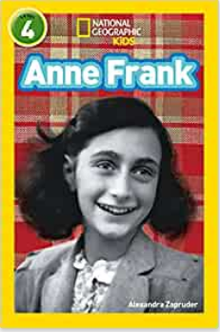 | 6/22 | This level 4 reader brings an understanding of her historical significance to a whole new audience. Young readers will learn about the brave and tragic life of the young girl whose diary kept while in hiding from Nazis is one of the most important and insightful books of the World War II era. National Geographic Readers: Anne Frank explores not just the diary, but her life and the important role she played in 20th-century history.
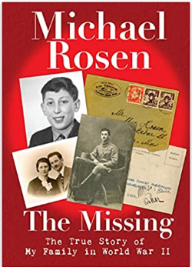 | 11/22 | A personal, powerful and resonant account of the Holocaust by one of this country's best-loved children’s authors. By turns charming, shocking and heart-breaking, this is the true story of Michael Rosen’s search for his relatives who “went missing” during the Second World War – told through prose, poetry, maps and pictures.  When Michael was growing up, stories often hung in the air about his great-uncles: one was a clock-mender and the other a dentist. They were there before the war, his dad would say, and weren’t after.  Over many years, Michael tried to find out exactly what happened: he interviewed family members, scoured the internet, pored over books and traveled to America and France. The story he uncovered was one of terrible persecution – and it has inspired his poetry for years since.  Here, poems old and new are balanced against an immensely readable narrative; both an extraordinary account and a powerful tool for talking to children about the Holocaust.
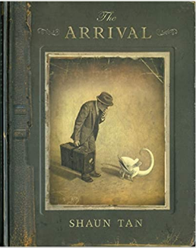 | 1/20 | What drives so many to leave everything behind and journey alone to a mysterious country, a place without family or friends, where everything is nameless and the future is unknown. This silent graphic novel is the story of every migrant, every refugee, every displaced person, and a tribute to all those who have made the journey.  THE ARRIVAL has become one of the most critically acclaimed books of recent years, a wordless masterpiece that describes a world beyond any familiar time or place.

