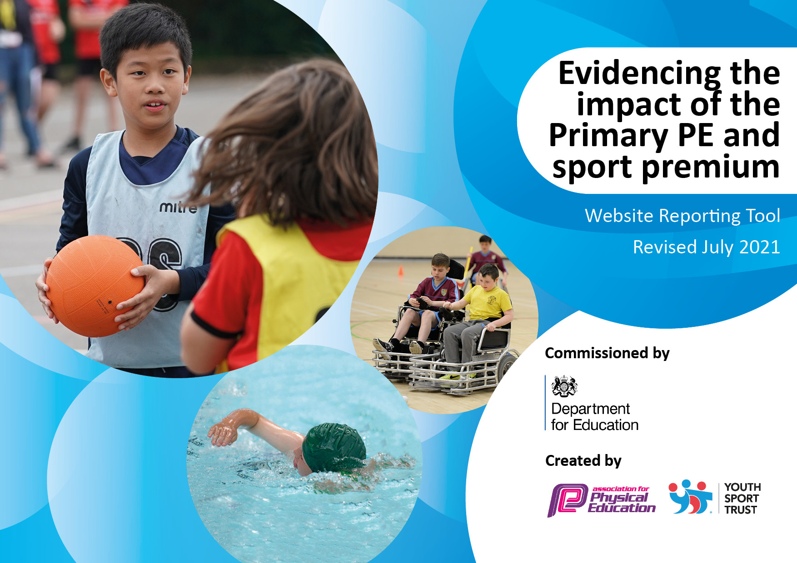
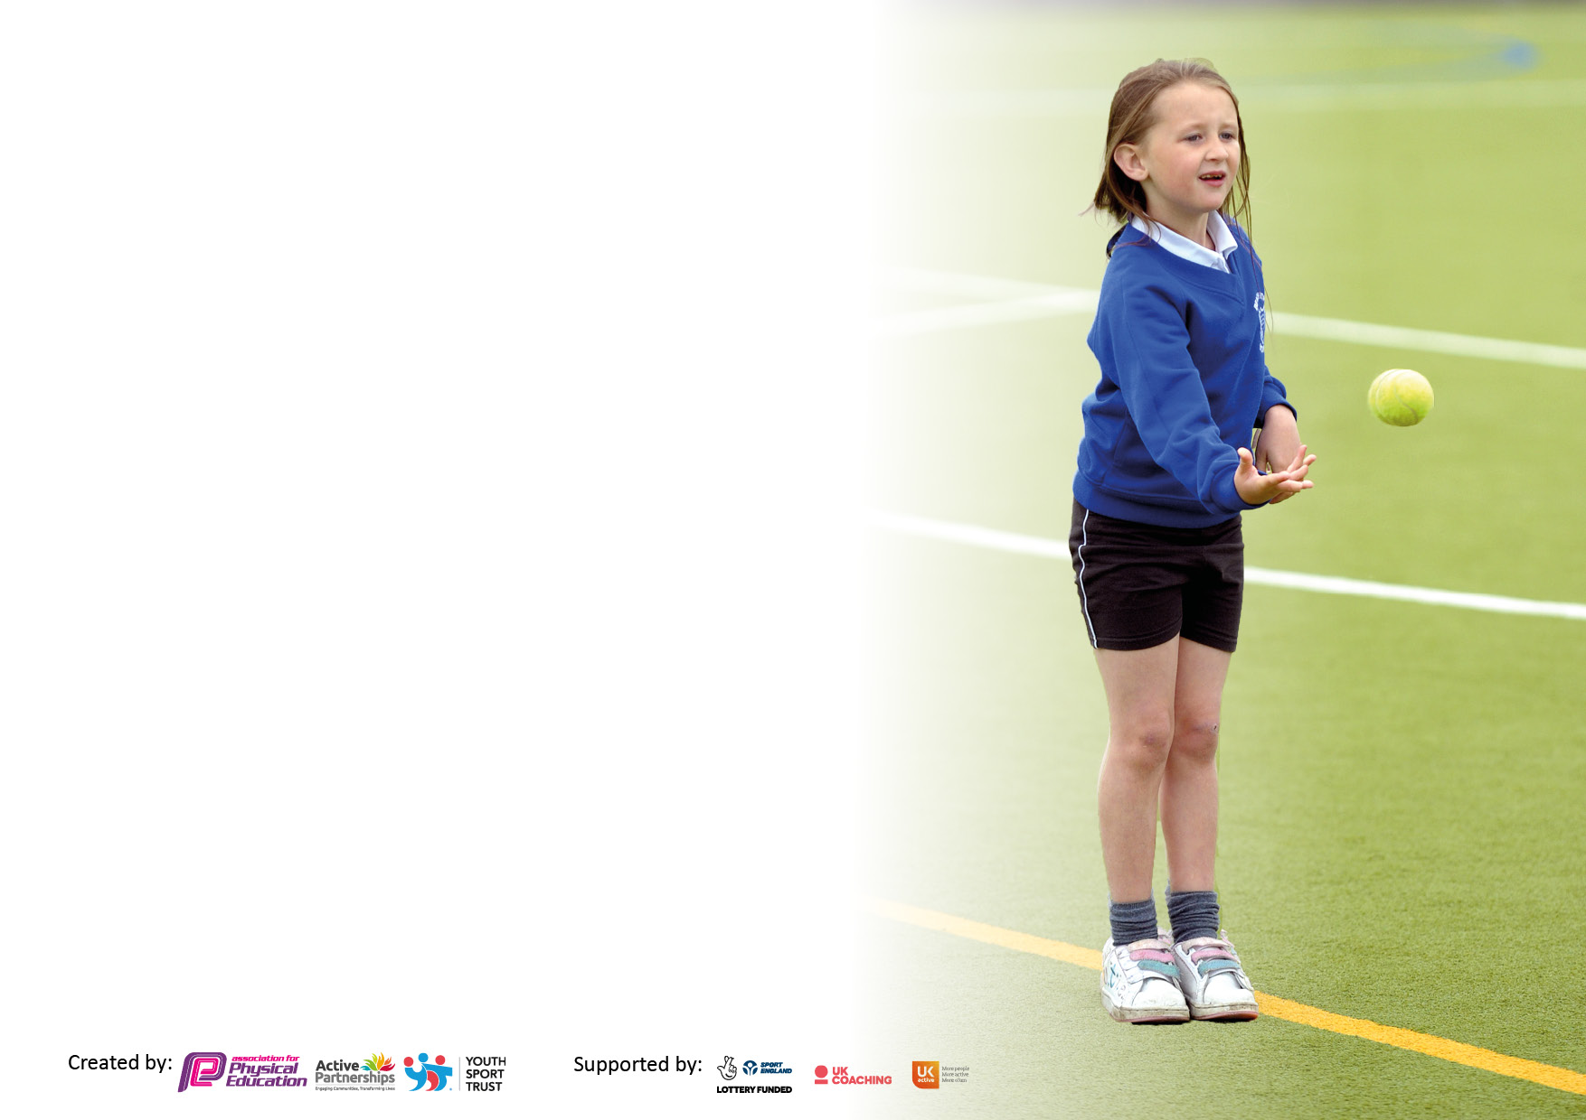

It is important that your grant is used effectively and based on school need. The Education Inspection Framework makes clear there will be a focus on ‘whether leaders and those responsible for governors all understand their respective roles and perform these in a way that enhances the effectiveness of the school’.

Under the Quality of Education Ofsted inspectors consider:
Intent - Curriculum design, coverage and appropriateness
Implementation - Curriculum delivery, Teaching (pedagogy) and Assessment
Impact - Attainment and progress

To assist schools with common transferable language this template has been developed to utilise the same three headings which should make your plans easily transferable between working documents.

Schools must use the funding to make additional and sustainable improvements to the quality of Physical Education, School Sport and Physical Activity (PESSPA) they offer. This means that you should use the Primary PE and sport premium to:

- Develop or add to the PESSPA activities that your school already offer
- Build capacity and capability within the school to ensure that improvements made now will benefit pupils joining the school in future years
- The Primary PE and sport premium should not be used to fund capital spend projects; the school’s budget should fund these.

Pleasevisitgov.ukfortherevisedDfEguidanceincludingthe5keyindicatorsacrosswhichschoolsshoulddemonstrate animprovement.Thisdocumentwillhelpyoutoreviewyourprovisionandtoreportyourspend.DfEencouragesschools to use this template as an effective way of meeting the reporting requirements of the Primary PE and sport premium.

We recommend you start by reflecting on the impact of current provision and reviewing the previous spend.

Schools are required to publish details of how they spend this funding, including any under-spend from 2019/2020, as well as on the impact it has on pupils’ PE and sport participation and attainment. All funding must be spent by 31st July 2022.

We recommend regularly updating the table and publishing it on your website throughout the year. This evidences your ongoing self-evaluation of how you are using the funding to secure maximum, sustainable impact. Final copy must be posted on your website by the end of the academic year and no later than the 31st July 2021. To see an example of how to complete the table please click HERE.
Created by: Supported by:

Details with regard to funding
Please complete the table below.

Total amount carried over from 2019/20 | £6859
Total amount allocated for 2020/21 | £16920
How much (if any) do you intend to carry over from this total fund into 2021/22? | £4685.41
Total amount allocated for 2021/22 | £16960
Total amount of funding for 2021/22. To be spent and reported on by 31st July 2022. | £21645.41
Swimming Data
Please report on your Swimming Data below.

Meeting national curriculum requirements for swimming and water safety.

N.B. Complete this section to your best ability. For example you might have practised safe self-rescue techniques on dry land which you can then transfer to the pool when school swimming restarts.
Due to exceptional circumstances priority should be given to ensuring that pupils can perform safe self rescue even if they do not fully meet the first two requirements of the NC programme of study
What percentage of your current Year 6 cohort swim competently, confidently and proficiently over a distance of at least 25 metres?  N.B. Even though your pupils may swim in another year please report on their attainment on leaving primary school at the end of the summer term 2020.  Please see note above | 81%
What percentage of your current Year 6 cohort use a range of strokes effectively [for example, front crawl, backstroke and breaststroke]?  Please see note above | 81%
What percentage of your current Year 6 cohort perform safe self-rescue in different water-based situations? | 81%
Schools can choose to use the Primary PE and sport premium to provide additional provision for swimming but this must be for activity over and above the national curriculum requirements. Have you used it in this way? | Yes (additional lessons for specific pupils)

Action Plan and Budget Tracking
Capture your intended annual spend against the 5 key indicators. Clarify the success criteria and evidence of impact that you intend to measure to evaluate for pupils today and for the future.

Academic Year: 2020/21 | Total fund allocated: | Date Updated:
Key indicator 1: The engagement of all pupils in regular physical activity – Chief Medical Officers guidelines recommend that primary school pupils undertake at least 30 minutes of physical activity a day in school |  |  |  | Percentage of total allocation:
 |  |  |  | %
Intent | Implementation |  | Impact
Your school focus should be clear what you want the pupils to know and be able to do and about  what they need to learn and to  consolidate through practice: | Make sure your actions to achieve are linked to your intentions: | Funding allocated: | Evidence of impact: what do pupils now know and what can they now do? What has changed?: | Sustainability and suggested next steps:
Ensure children undertake at least 30 mins per day of physical activity in school. (Better physical health, improved academic performance, concentration and self-confidence.)  Ensure the children can access enough space so that they can play actively including larger sports pitch areas.  Develop use of play zones so that playtime provision is broad, active & purposeful. Raise physical activity levels of children at playtime through structured activity and focused resources. Develop gross motor skills of pupils in EYFS and KS1. Raise physical activity levels of children at playtime. | Use of professional coaches to lead games for 1hr 1x per week per class Use of sports coach for PP children and those who need extra team building skills or extra fitness. Use of sports coach for active play.  Use of the cricket field to give children more space to play as school site is small and crowded. Safeguard the agreement for the use of the cricket field for the future through a legal agreement with the cricket club who can sublet the land they currently occupy.  Establish & maintain activity zones in the playground to help maximise active play areas. Purchase equipment to engage and excite children and help promote even higher levels of physical activity. Develop additional area of school grounds to include balancing and climbing activities to develop core strength. | £10000  £1600  £2500 | All classes have received this – 3 terms per class. Children’s skills have visibly improved throughout school. Pupils building social skills and gaining the extra fitness needed. Organised games available x3 per week at lunch.  Children will be able to access the neighbouring playing field/cricket pitch up to 2036 under a formal sublease with the cricket club.  Children are focused and happy and as active as possible during lunchtimes. Children are more confident and levels of concentration and stamina improve. Children’s skills and balance have visibly improved throughout school. | Monitor participation in sport of children who appear less fit / overweight.  Ensure the lease is checked regularly and reviewed as needed. Ensure conditions within the lease are met. (eg grass cutting)  Pupils are active throughout lunchtimes. Pupils improve their core strength and balance which can be built upon in PE lessons.
Key indicator 2: The profile of PESSPA being raised across the school as a tool for whole school improvement |  |  |  | Percentage of total allocation:
 |  |  |  | %
Intent | Implementation |  | Impact
Your school focus should be clear what you want the pupils to know and be able to do and about  what they need to learn and to  consolidate through practice: | Make sure your actions to achieve are linked to your intentions: | Funding allocated: | Evidence of impact: what do pupils now know and what can they now do? What has changed?: | Sustainability and suggested next steps:
Increase awareness/interest in sport across the school.  Raise the profile of sport, PE, dance and physical activity with parents.  All pupils in KS2 encouraged to participate in dance and have the chance to perform to an audience. | Celebration of sporting achievements, in and out of school, in Golden assembly. Termly Sportsperson of the term award. Sports noticeboard Trophies for competitions Sports captains Website / Newsletter  Develop the use of the school website and Twitter. Detail developments and success stories in the school’s newsletter and on Twitter/Facebook.  Involvement in the Churchill cluster Dance Festival event for KS2. Costumes/equipment required for performance to be purchased if needed to support raising the profile of dance. | £200  (Approx staff time) £500  £500 | Children interested in sports noticeboard and photos. Children visibly proud of sporting success and pride in school team achievements.  Sport and physical activity is celebrated and children feel enthused to lead active, healthy lifestyles.  Children enjoy taking part in performance and watching other schools perform. Children proud of their success and achievement. | Improve PE website – update more often.  Ensure regular blog maintained on website/class pages includes outdoor activity.  Ensure future attendance, begin a dance club afterschool to continue momentum.

Key indicator 3: Increased confidence, knowledge and skills of all staff in teaching PE and sport |  |  |  | Percentage of total allocation:
 |  |  |  | %
Intent | Implementation |  | Impact
Your school focus should be clear | Make sure your actions to | Funding | Evidence of impact: what do | Sustainability and suggested
what you want the pupils to know | achieve are linked to your | allocated: | pupils now know and what | next steps:
and be able to do and about | intentions: |  | can they now do? What has
what they need to learn and to |  |  | changed?:
consolidate through practice:
Develop confidence in using PE scheme of work training /new staff who have no previous knowledge of PE scheme.  Children will be able to take part in mini physical and sports activities at lunchtimes and break times with the support of adults on duty. | Continuous CPD through observing visiting coaches. (release cover)  Training for lunch staff in organising and playing mini games on the field and playground. (School Sports Teaching Coach) Overtime payments to lunch staff to ensure attendance. | £500  £500 | Through staff consultation it is evident that staff are aware of more skill-based games to use when teaching PE. They also have a better understanding of how to progress an activity or to make it more accessible to individuals.  Lunch staff will be more confident to support with the set up and organisation of small sports based games. | Continue to build staff confidence in using the new scheme.  Staff to ensure activities are started daily with the support of the sports captains.
Key indicator 4: Broader experience of a range of sports and activities offered to all pupils |  |  |  | Percentage of total allocation:
Intent | Implementation |  | Impact
Your school focus should be clear | Make sure your actions to | Funding | Evidence of impact: what do | Sustainability and suggested
what you want the pupils to know | achieve are linked to your | allocated: | pupils now know and what | next steps:
and be able to do and about | intentions: |  | can they now do? What has
what they need to learn and to |  |  | changed?:
consolidate through practice:
Additional achievements:  Niche sports taught weekly across the school  Niche sports taster days and events to introduce children to a range of niche sports and physical activities. | Use of sports coach to deliver niche sports: Archery, bocca, curling etc. 1 afternoon session per 4 weeks. Introduce children to new niche sports at Multi-sport events.  Sports activity days for all pupils from recognised sports coaches (archery, golf, tennis, yoga etc) | £2000  £1000 | Pupils have experience of a wide range of sports. | Continue to promote. Explore new opportunities when they arise. Take part in more events next year. (After relaxation of covid guidelines)

Key indicator 5: Increased participation in competitive sport |  |  |  | Percentage of total allocation:
 |  |  |  | %
Intent | Implementation |  | Impact
Your school focus should be clear | Make sure your actions to | Funding | Evidence of impact: what do | Sustainability and suggested
what you want the pupils to know | achieve are linked to your | allocated: | pupils now know and what | next steps:
and be able to do and about | intentions: |  | can they now do? What has
what they need to learn and to |  |  | changed?:
consolidate through practice:
Membership of North Somerset Schools PE Association (NSSPEA) to September 2023.  100% of KS2 children to represent their school in a festival/L1/L2 competition. (To be used to do this within school if prevented due to covid) | Engage fully with the NSSPEA offer  Enter festivals, L1 and L2 events where possible. (when restarted post Covid regulations) Regular inter-house competitions take place in school and within classes | £1600  £500 (lower than usual amount allocated due to reduction in possible off site activities) | Engagement in the NSSPEA offer puts physical activity and wellbeing at the heart of school life. The school is well supported in meeting the 5 Primary PE and Sport Premium outcomes and developing high quality, sustainable provision. | Take part in more events next year. (After relaxation of covid guidelines)

Signed off by
Head Teacher: | J Campbell
Date:
Subject Leader: | J Campbell
Date:
Governor: | CM
Date:

